**RIPHAH INTERNATIONAL UNIVERSITY ISLAMABAD**



Assesment#1

Bachelors of Computer Science – 5th Semester

Subject: Operating System

Submitted to: Miss Kousar

Submitted by: Maryum Malik

Sap ID: 45369

**Lab Task 1**

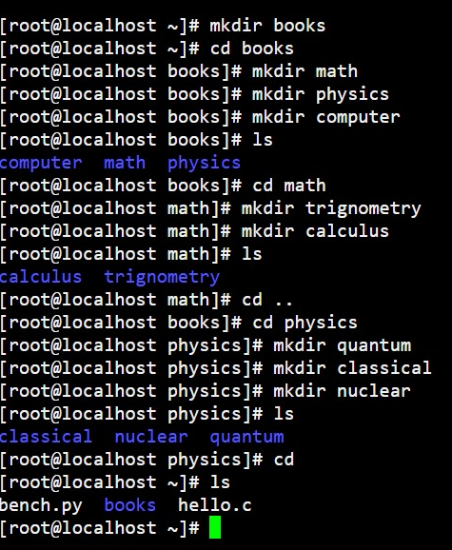

**Lab Task 2**

**Common Linux Directory Commands (Simplified)**

1. **pwd:**

Shows your current directory.

**Example:** pwd

1. **ls:**

Lists files and directories in your current location.

**Example:** ls

1. **cd:**

Changes to another directory.

**Example:** cd /home/user/Documents

1. **mkdir:**

Creates a new directory.

**Example:** mkdir new_folder

1. **rmdir:**

Deletes an empty directory.

**Example:** rmdir old_folder

1. **rm -r:**

Deletes a directory and its contents.

**Example**: rm -r folder_to_delete

1. **cp**: Copies files or directories.

**Example:** cp file.txt /path/to/destination

1. **mv:** Moves or renames files or directories.

**Example:** mv file.txt new_location/

**What is BASH?**

BASH (Bourne Again Shell) is the default shell in Linux used for running commands and writing scripts. It helps you interact with the system and automate tasks. You can customize it through configuration files like .bashrc.

**Simple script example:**

#!/bin/bash

cp /home/user/Documents/*.txt /home/user/Backup/

**Lab Task 3**

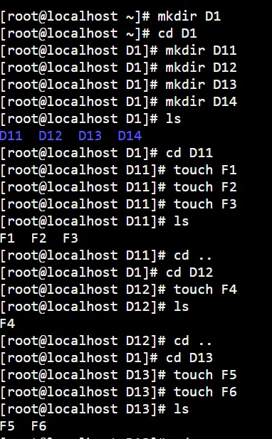

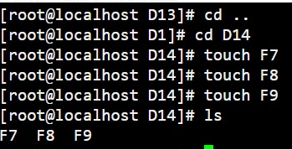

**Lab Task 4**

